Project Definitions

Azure Terraform:

Project-1: Design a Banking System (API Driven, 3 Tier) with Azure - Terraform

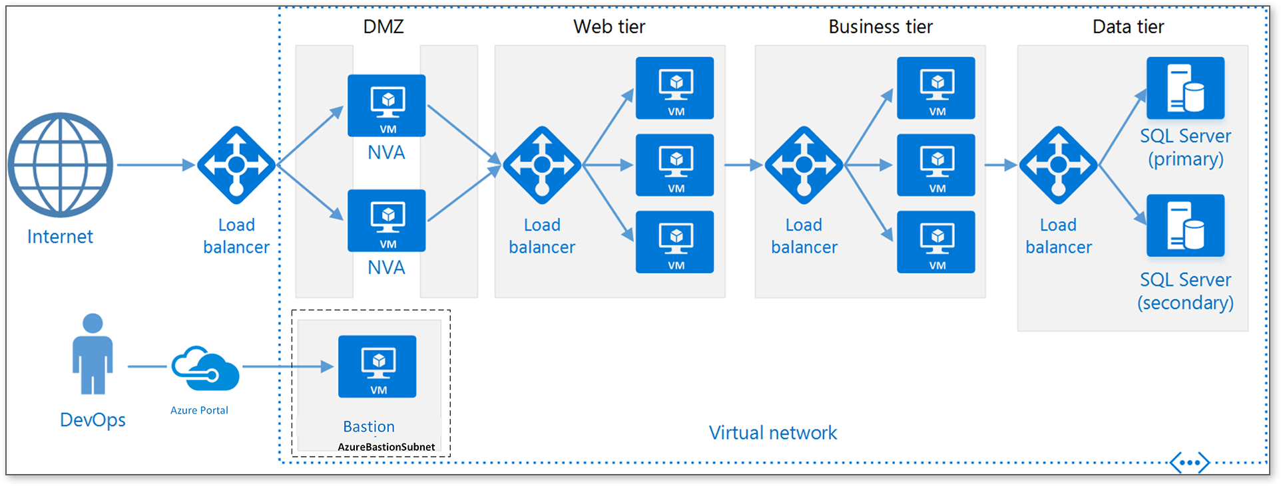

* VNet
* VNet-Subnets
* Firewalls
* Domain
* Bastion Hosts
* Front-End Gateway Load Balancer
* Web-Servers (Azure Scale Sets with VMs)
* Backend Load Balancer
* Business Tier Servers (Azure Scale Sets with VMs)
* Data Tier - SQL Servers (Primary and Secondary)

1. **Region Preference**: ca-cetnral-1
2. **SQL Server Configuration**: Do you want the **Primary** and **Secondary** SQL servers in **failover mode**
3. **Domain Configuration**: I have a domain binna.ca that I would like to use it.
4. **SSL/TLS for WAF**: Cconfigure an **SSL certificate** for the **Web Application Firewall (WAF)**
5. **Deployment Method**: I prefer **Terraform modules** for each tier
6. **Compute Configuration**: **Spot instances if possible**